**Ideation Phase**

**Define the Problem Statements**

|  |  |
| --- | --- |
| Date | 10 October 2022 |
| Team ID | PNT2022TMID19738 |
| Project Name | NEWS TRACKER APPLICATION |
| Maximum Marks | 2 Marks |

**Customer Problem Statement:**

As our lives are very busy these days, we often feel we need more than 24 hrs. a day to cope up with everything we have in our schedule. Well, that's not possible but reducing the time by changing the conventional method of reading news can help. Just tell us what market news you're interested in and get a quick peek for the day. Only read what you feel is relevant and save your time. This app helps you to query for all information about Indices, Commodities, Currencies, Future Rates, Bonds, etc.… as on official websites.

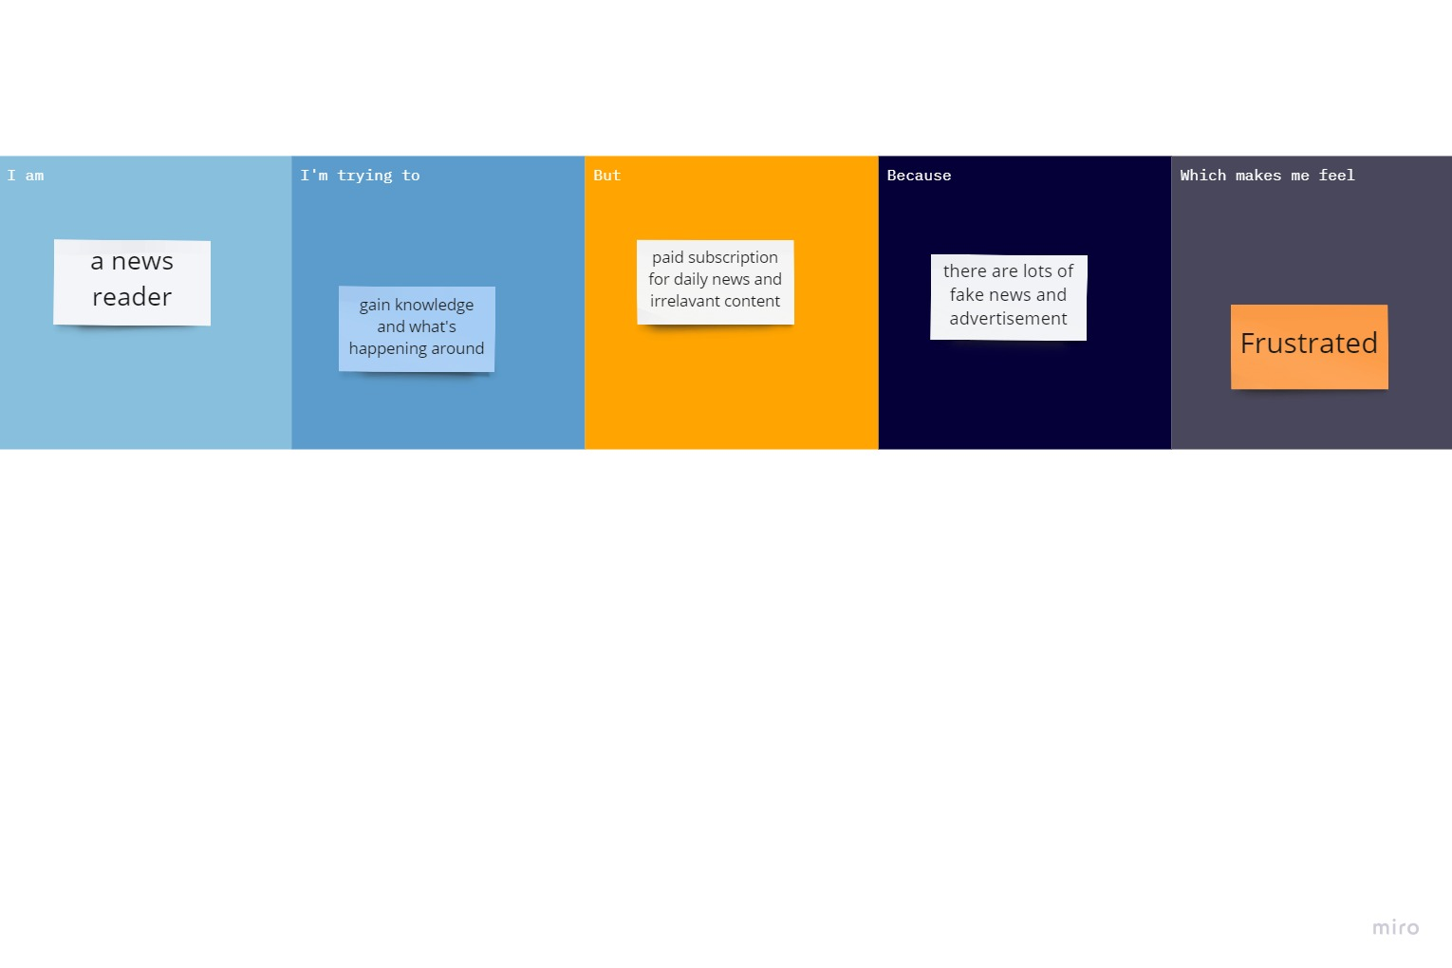

|  |  |  |  |  |  |
| --- | --- | --- | --- | --- | --- |
| **Problem Statement (PS)** | **I am (Customer)** | **I’m trying to** | **But** | **Because** | **Which makes me feel** |
| PS-1 | A news reader | Gain knowledge | Paid subscription for daily news | Lots of fake news | Frustrated |
| PS-2 | A news reader | Information about the surrounding | Irrelevant content of news | Advertisements | Disappointed |